CA-10
2016 IE Strategy Memorandum
Updated on 5/17/16

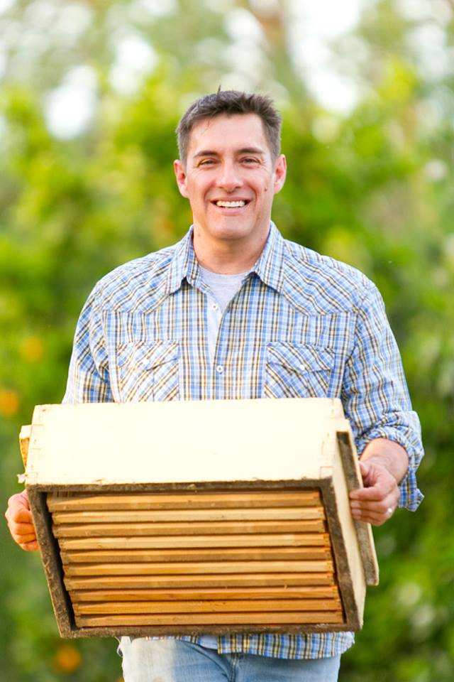
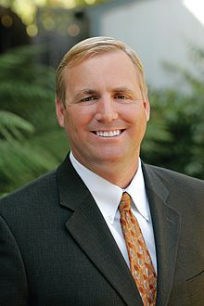

MICHAEL EGGMAN CONGRESSMAN JEFF DENHAM
CoH: $370,153.79 CoH: $2,428,506
Date: 4/15/16 Date: 4/15/16
Occupation: Almond Farmer/Beekeeper Occupation: Businessman/Farmer/Representative


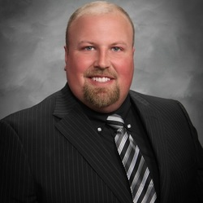

MICHAEL BARKLEY ROBERT HODGES
CoH: $524 CoH: $0
Date: 4/15/16 Date: 4/15/16
Occupation: Lawyer/CPA/Programmer Occupation: Farmer

SECTION I: Race Overview
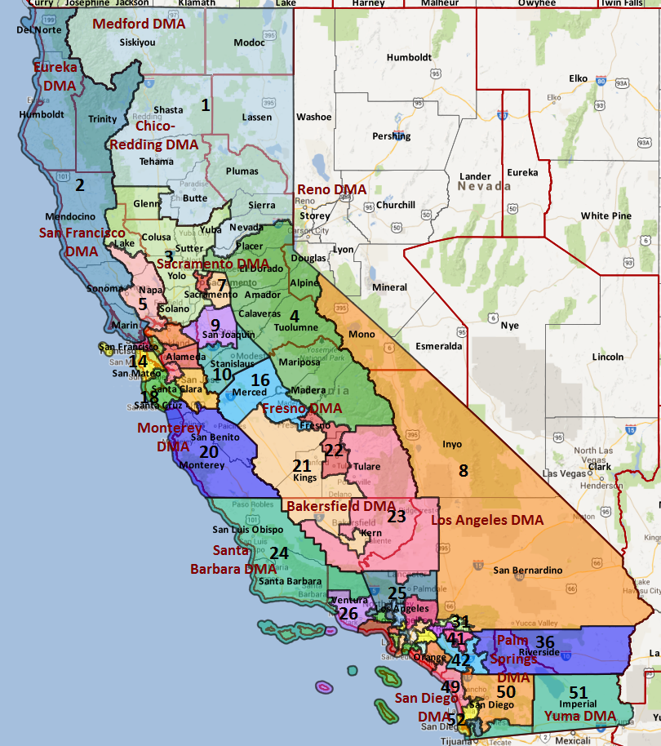

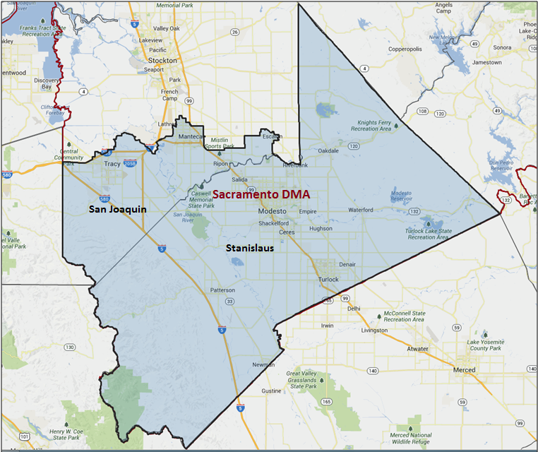

Media Market Costs

TV DMA | % of  CD | I.E.  35+ CPP | Cable CPP
SACRAMENTO | 100% | $575 | $800
CA-10 TOTALS: | 100.0% | $575
Radio Landscape

Stockton
Universe Size | CPP
352,600 | $65

Modesto
Universe Size | CPP
262,800 | $65

Digital Landscape
- CA-10
  - Persuasion universe size: 24,669
  - Audience extension (key demos): Hispanic, 18-30
  - Weekly budget for full coverage: $9,030.22
  - Reach
    - YouTube - 325,960
    - Pandora - 212,555

Presidential Statistics
Cycle | Candidate | Party | Vote
2012 | Obama | DEM | 51.8%
2012 | Romney | REP | 48.2%
2008 | Obama | DEM | 51.2%
2008 | McCain | REP | 48.8%

Congressional Statistics
Cycle | W/L | Candidate | Party | Vote
2014 | L | EGGMAN | DEM | 43.8%
2014 | W | DENHAM | REP | 56.1%
2012 | L | HERNANDEZ | DEM | 47.3%
2012 | W | DENHAM | REP | 52.7%

NCEC Data
Dem Performance: 49.6%
BVAP: 3.8%
Hispanic: 28.1%
Asian: 7.3%
Total Minority: 39.2%

Critical Dates
Filing Date: March 25th 2016
Primary Date: June 7th 2016

Summary of 2014 Cycle Spending by Outside Groups to Date

None

Summary of 2012 Spending by Outside Groups

TV Competitive Summary -- Sacramento
Campaign/Group | GRPs | Total Dollars
Hernandez / DCCC | 253 | $78,550
DCCC | 5750 | $2,746,591
NRCC | 1970 | $1,143,459
House Majority PAC | 1050 | $387,491
House Majority PAC Hispanic | 411 | $52,625
AFSCME (Hispanic TV) | 331 | $82,775
Chamber of Commerce | 612 | $504,612
American Action Network | 2652 | $2,595,938
Good Guys v. Bad Guys | GRPs | Total Dollars
Good Guys | 7,795 | $3,348,032
Bad Guys | 5,234 | $4,244,009
Pre-Election Day Voting

Type of  “Early Voting” | Start Date  End Date | Percent of  Vote Cast Using this Method | Brief Description  (where/how  do people vote) | Timeframe (when does the majority of voting happen)
Early Vote | Oct 8 –Nov 8 |  | Voters can bring their early ballots to the board of elections office or be issued a ballot at the office at the time of their visit | Steadily between Oct 8 – Nov 7
Absentee Ballot/In person Absentee | Oct 10 – Nov 11 |  | Voters must apply for an absentee/VBM ballot via mail, online, or in person | Absentee applications must be received by BOE at least 7 days before election day
Vote By Mail | Oct 1 – Nov 11 |  | Voters must request to VBM each election unless on PEVL - VBM must be received by BOE by Nov 11 and be postmarked before election day | Ballots return steadily.

IMPORTANT DATES
Early Vote: 8 – Nov 8
VBM: Oct 10 – Nov 11

- Counties begin sending out absentee ballots on 10/10/2016. Voters can apply for PAV status by mail until 11/1/2016 and can apply in person after that date. Registered voters of Stanislaus County may vote at the Registrar of Voters Office beginning 29 days prior to every election. San Joaquin County sometimes offers early voting as well.
- In 2012, 66.6% of ballots were cast via mail. Most mail ballots in the district arrived late. Only 7% of mail ballots were returned in the first week of VBM voting (week 4) and 27% of ballots were returned before two weeks out from Election Day. Just over half (53%) of VBM ballots arrived prior to the final week, while the outstanding 47% of VBM ballots arrived in the final week of the election.
- In 2012, the registered party composition of vote-by-mail votes was slightly less favorable than Election Day partisanship. Returned ballots from registered Democrats and Republicans were evenly split (41% each with 18% from registered DTS voters), while 40% of Election Day voters were Democrats compared to 39% of Republicans.
- A similar pattern occurred during the 2014 vote-by-mail period. 73.4% of ballots in 2014 were cast by mail. More than 15% of ballots were turned by week 3, nearly 40% of ballots were returned by week two with and 70% of ballots were returned by week 1.
- According to official election results, Hernandez won 46.4% of VBM votes and 49.1% of poll votes in 2012. He performed only slightly better with San Joaquin VBM voters compared to Stanislaus VBM voters (47.6% vs. 46.0%). Therefore, if Eggman can match Hernandez’s Election Day support rate of 49.1%, Eggman would need to win 53.8% of mail votes.

SECTION II: DISTRICT OVERVIEW

- District Overview and Data

  - Political Landscape
- Hispanic beekeeper Michael Eggman is challenging Republican Congressman Jeff Denham in 2016, setting up a rematch of the 2014 contest. As an experienced candidate, Eggman has already outpaced his fundraising from last cycle, a major drag on his first run. Early polling conducted by the DCCC also shows that Eggman has maintained his standing with voters since 2014 and is in a good position to build upon his first campaign.
- Originally a farmer and small business owner, Denham has been in public office since 2002, serving as a State Senator for two terms before running for Congress. Denham now sits on the House Committee on Transportation and Infrastructure, the Agriculture Committee, and the Natural Resources Committee.
- Per a DCCC poll conducted in October, Denham beats Eggman by 13 points (37% to 24%), but 39% of the electorate was undecided. When asked if they would vote to reelect Denham or vote for someone else, 28% of respondents said they would vote for someone else and 37% were undecided. The generic ballot was much closer, as the generic Republican had an 8-point lead over the generic Democrat (38% to 30% with 32% undecided).

  - District Demographics
- Located in Northern California, CA-10 includes the cities of Modesto, Turlock and Oakdale. CA-10 falls entirely within the Central Valley agriculture belt (16.6% rural) and includes part of San Joaquin County and all of Stanislaus County.
- The district is covered entirely by the expensive Sacramento-Stockton-Modesto media market, which has a $261 candidate cost per point.
- The district is a mix of tiny agriculture towns, bedroom communities for San Francisco commuters looking for more affordable housing, and midsize cities. CA-10 is heavily Hispanic/ Latino (28.1% Hispanic/ Latino Citizen Voting Age Population), uneducated compared to the state average (only 17.7% of the population graduated college) and has experienced high levels of unemployment (14.5% unemployment rate). While Hispanic voters live throughout the district, African American populations are clustered around the outskirts of Tracy and Modesto. A higher proportion of AAPI voters reside in Tracy, north of Modesto, Turlock and Oakdale.
- Voters in California register with a party or “decline to state.” Unless otherwise noted, party references in this document refer to party registration.

District Demographics

- Cook Partisan Voting Index: Lean Rep
- Urban Population: 28.5%
- Rural Population: 16.6%
- Suburban Population: 54.9%
- Median Income: $54,681
- Poverty Status: 11.6%
- Military Veterans: 8%
- Race/Ethnic Origin: 60.8% White; 3.8% Black; 7.3% Asian; 28.1% Hispanic Origin

  - Electoral Context
- The Senate race’s effect on the Congressional race will depend on the outcome of the jungle primary; however, this district has not traditionally been a part of a statewide path to victory. As a result, Eggman is unlikely to benefit from top of ticket spending.
- As of October 2015, Hillary Clinton was unpopular in the district (35% fav to 49% unfav, with 15% undecided), and two potential Republican nominees would be particularly problematic in this district. CA-10’s White, lower income, rural voters fit the profile for Trump supporters, while Rubio would capture many of the crossover Democratic Hispanics/Latinos that Denham traditionally wins.
- It is now much easier for a ballot initiative to qualify for the ballot, and we therefore expect a very high number of ballot measures to appear in 2016. Ballot initiatives that may impact the electorate include:
- A “Fight for $15” minimum wage increase that is being sponsored by SEIU
- A possible initiative that will legalize the recreational use of marijuana
- A ban of the possession and sale of large ammunition clips
- Proposition 30 extensions that would continue higher income tax for the wealthiest Californians
- School Funding and Budget Stability Act that would extend Prop 30’s income tax increases through 2030 and fund K-14 education
- The “Invest in California’s Children Act,” which would impose higher rates on individual tax filers earning more than $1 million per year
- One major rule change will impact our races in 2016. Senate Bill 29 rules that boards of elections must count absentee ballots that arrive up to three days after the election that are postmarked on or before Election Day. Previously,only ballots received by Election Day were counted. The new DMV voter registration legislation, known widely as “New Motor Voter,” will not be in effect prior to the 2016 cycle

  - Press Presence
The district is covered entirely by the expensive Sacramento-Stockton-Modesto media market, which has a $261 candidate cost per point.
The Sacramento media market is crowded with state politics, busy with CA-07, and world’s away from CA-10. This is a very challenging

TV:
- KCRA sometimes has a camera down in Modesto, but it is unreliable
- Eggman has left Spanish TV untapped

Radio:
- Conservative talk

Print/Digital
- Paper of Record: The Modesto Bee
  - Editor Joe Kieta and Editorial Page Editor Mike Dunbar
    - They currently do not have the budget for a political reporter
- Merced Sun Star
- McClatchy - Mike Doyle
- Turlock Journal

SECTION III: MESSAGE

Message Box

Democrat Self Frame  Michael Eggman is a family farmer who understands the struggles of Central Valley families and is ready to fight for them in Congress. Traveling up and down the Central Valley in his pickup truck to pollinate crops for local farmers, Michael understands the hardships faced by local families and business owners.  As a father and husband, Michael knows how tough it is for families to make ends meet.  We need a leader who understands the importance of finding a good job, the challenges of paying for a college education, and the need to protect our family farms. Michael is the only candidate with a vision to grow our economy and expand opportunity for Valley families. | Republican Self Frame  Denham is farmer who stands up for the Valley in Congress, including leading the way to stop High Speed Rail and bring water to the Valley.
Likeliest Attacks on Democrat  Receives contributions from environmental supporters opposed to drought relief for the Central Valley.  Recruited by and beholden to Pelosi, Obama, Washington Democrats. | Best Attacks on Republican  Jeff Denham is a Washington insider who is out of touch with Central Valley families.  Too extreme on social issues, especially women.

- Michael Eggman (D)

- Short Biography
Growing up on a farm in Turlock, Michael helped his parents run the family business.Today, Michael still farms the same land he grew up on, operating an almond orchard and managing thousands of beehives that produce honey for families all across the state. Michael is married to his college sweetheart, Stacey, and they have two daughters together.

- Self-Frame
Michael Eggman is a family farmer who understands the struggles of Central Valley families and is ready to fight for them in Congress. Traveling up and down the Central Valley in his pickup truck to pollinate crops for local farmers, Michael understands the hardships faced by local families and business owners.
As a father and husband, Michael knows how tough it is for families to make ends meet.
We need a leader who understands the importance of finding a good job, the challenges of paying for a college education, and the need to protect our family farms. Michael is the only candidate with a vision to grow our economy and expand opportunity for Valley families.

- Likely Attacks
Receives contributions from environmental supporters opposed to drought relief for the Central Valley.
Recruited by and beholden to Pelosi, Obama, Washington Democrats.

- Assessment of Democratic Fundraising
DEMOCRAT | Q2 2015 | Q3 2015 | Q4 2015 | Q1 2016
Goal | $150,000 | $310,000 | $250,000 | $300,000
Actual Raised | $142,242 | $144,344 | $141,224 | $112,907.95

- Strengths and Weaknesses of Campaign

- Market:
  - CA-10 is in the Sacramento media market, making it tough to get any TV coverage. The market is crowded and often focused on the activity in the state government, and TV reporters will rarely travel down to Modesto.
  - The Modesto Bee is the paper of record here, but is less involved in politics than its counterpart in Sacramento.
- Infrastructure:
  - There is no history of Democratic politics in this district, and a very small bench of potential candidates.
  - The Condits are the strongest political force on the Democratic side -- and they have very weak ties to the Democratic establishment and brand. The younger Condit children are likely to make a play for this seat in the future, and Assemblyman Adam Grey (who is married to a Condit) is the most popular current Democratic elected official in the area. Asm. Grey has consistent fights with Democratic leadership, and lives about 40 minutes outside CA-10’s district lines.
  - The Democratic party establishment is essentially non-existent. The party leadership that exists is undergoing new leadership, including Joe Souza who begun in 2015 -- but none of the structure is a strong force on the ground.
- Candidate:
  - The candidate fits the district well -- but that includes dealing with many of the personal issues with which residents of CA-10 deal daily. Eggman’s income comes from his farming business, the bulk of which comes from his bees and the honey he sells. Eggman started with over 1600 bees before his first run for Congress, and is down to under 300 bees after losing half after his first run.
  - Eggman was very undecided about making the run, and has remained indecisive about staying in the race -- both due to his failing business and concern about the investment from the DCCC.
  - Eggman lacks a personal network from which to raise money, but runs a professional operation with a strong campaign manager and finance director, and is committed to call-time.

- Jeff Denham (R)

- Short Biography
U.S. Representative Jeff Denham is a Valley farmer, small businessman and veteran, first elected to Congress in 2010.
Jeff served on active and reserve status in the U.S. Air Force for 16 years. He is a recipient of the meritorious service medal for his service in Operation Desert Storm (Iraq) and Operation Restore Hope (Somalia). Denham was awarded the “Order of California” for exceptional meritorious service by the California National Guard; the highest award possible given for distinguished service.
After graduating from California Polytechnic State University, San Luis Obispo, Rep. Denham began working in the agriculture field, where he has since started several successful agriculture-based businesses.

- Self-Frame
Denham is farmer who stands up for the Valley in Congress, including leading the way to stop High Speed Rail and bring water to the Valley.

- Best Attacks

Republican Candidate | Ryan Budget(s) – (Include if its Votes or Statement) | Privatize Social Security | Defund Planned Parenthood | Anti-Choice Position
Denham | Released statement supporting Ryan budget in 2014 |  | X | X

Denham Top Hits

- He has gone Washington—currently lives with his family in McLean, VA and his wealth has increased greatly since he became a Congressman
- Inconsistent immigration record—says he supports comprehensive immigration reform but voted for Paul Ryan as speaker despite his refusal to bring the issue to a vote
- Has not done anything significant for the district’s drought issues
- Voted for Ryan budget which effectively ends Medicare as we know it
- Opposed DREAM Act

SECTION V: Appendix

- 2016 Campaign Side Consulting Team
Media: Three Point Media - lead: Goldman
Mail: Mission Control - lead: Greven, Peavy
Polling: ALG - lead: Murphy, Grove
Online/Digital: New Blue Interactive
Self-research: Grand Central Consulting - lead: Herbsman

- Summary of Past Races and Important Differences for 2016
Recent Elections
- Presidential performance in CA-10 has steadily improved in every election since 2004. President Obama carried this district in both 2012 and 2008 (51.8% and 51.2% respectively), winning by a slightly-higher margin in 2012 than he did in 2008 after Senator Kerry lost this district with 42.6% in 2004.
- At the congressional level, former astronaut and first-time candidate Jose Hernandez challenged Republican Jeff Denham in 2012. Hernandez raised more than $1.7 million, but was outspent by Denham 1.5 to 1. Despite the district’s slight Democratic registration advantage, Hernandez ultimately lost to the popular incumbent by 5.4 points.
- Local beekeeper and almond farmer Michael Eggman challenged Denham in 2014. First-time candidate Eggman trailed Denham by between 18 and 26 points in early polls and lacked a considerable network from which to fundraise. Eggman closed the gap by 14 points, but Denham was able to outspend and out-communicate Eggman in a Republican wave year.
- The district’s two counties performed similarly in the last Congressional election: Eggman received 44.4% support in San Joaquin County and 43.6% support in Stanislaus County. However, voters in San Joaquin were more supportive of Obama and Hernandez in 2012 than were voters in Stanislaus. Tracy, the second largest city in the district, is the most supportive of Democratic candidates while Modesto is the battleground: it comprises 36% of the vote share and has an average congressional support rate of 48%.
- The 2016 has been set at 49.6%, a 2.3 point increase over the 2012 and 2014 DPIs. Prior to this year the district has remained stable over the last two cycles with a 47.3% DPI in both 2012 and 2014.

Role of the I.E.
We decided that this would be a place where we poll to find out if there was a way to defeat Denham. We did not play here, even though the initial poll looked promising (showing a chance at a rare pickup). The tracker later in cycle, conveyed a less optimistic story.
Eggman’s campaign lacked the momentum (financially, politically) it needed to pose a serious threat to Denham. Eggman was also hurt by significantly lower turnout, especially among Hispanic voters. Polling conducted by the DCCC and by Eggman both suggested the race was closer than initially thought. However, Denham was sitting on large cash reserves he could tap if the DCCC went on air against him, putting this race effectively out of reach. In 2016, with higher expected Hispanic turnout, and very strong candidate, this seat could possibly be in play.

2016 Electorate
- Using the previous Presidential election as a guide, official Secretary of State records from 2012 indicate a turnout rate of 68.4% of registrants (215,113 votes cast).
- Applying the 2012 turnout rate forward to the current electorate as defined by the Secretary of State, we can expect that 202,794 voters, or 68.4% of the electorate, will cast ballots in the 2016 general election.
- As a result, a successful campaign will need 105,453 raw votes to reach a 52% support goal. A one-point shift in support equates to 2,028 raw votes.The projected 2016 electorate vote share will be 4.8% more Hispanic, 7.8% less White, 5.7% more young voters (aged 18-29) and 3.8% less Republican than the 2014 electorate.
- 2.7% of the district’s 2012 voters cast ballots for the Presidential contest but not the Congressional race. Additionally, Denham was significantly more popular than Romney in the district: 9.0% more voters cast ballots for Denham than Romney and 9.2% of Obama voters did not vote for Hernandez.
- Our key base targets are located in Tracy, Turlock, Oakdale, and Escalon, with persuasion targets located outside Tracy, in Patterson, and in Turlock. Our turnout targets are in the population centers of Tracy, Modesto, Turlock, Manteca, and Patterson.

DEMOCRATS START THIS RACE BEHIND BY APPROXIMATELY 11,500 VOTES (46.2% TWO-WAY SUPPORT). VICTORY DEPENDS ON THE FOLLOWING:
- CONSOLIDATE THE DEMOCRATIC BASE TO MINIMIZE DENHAM’S CROSSOVER APPEAL
- ACHIEVE A 74.2% SUPPORT RATE WITH HISPANICS/ LATINOS AND RAISE TURNOUT IN THE HISPANIC/LATINO COMMUNITY TO 68.7%
- WIN 59.1% OF INDEPENDENTS, WITH AN ABSOLUTE FLOOR OF 55.1%
- ACHIEVE 55.0% SUPPORT AMONG WOMEN
- ENGAGE VOTERS IN THE DISTRICT’S LARGEST CITIES TO ACHIEVE A 53.8% SUPPORT RATE IN MODESTO, AND A 61.5% SUPPORT RATE AND A 76.5% TURNOUT RATE IN TRACY
- WIN 51.5% OF VOTE-BY-MAIL BALLOTS AND 53.0% OF POLL BALLOTS

